Consider the Country table and Persons table that you created earlier and perform the following

1. Find the number of persons in each country

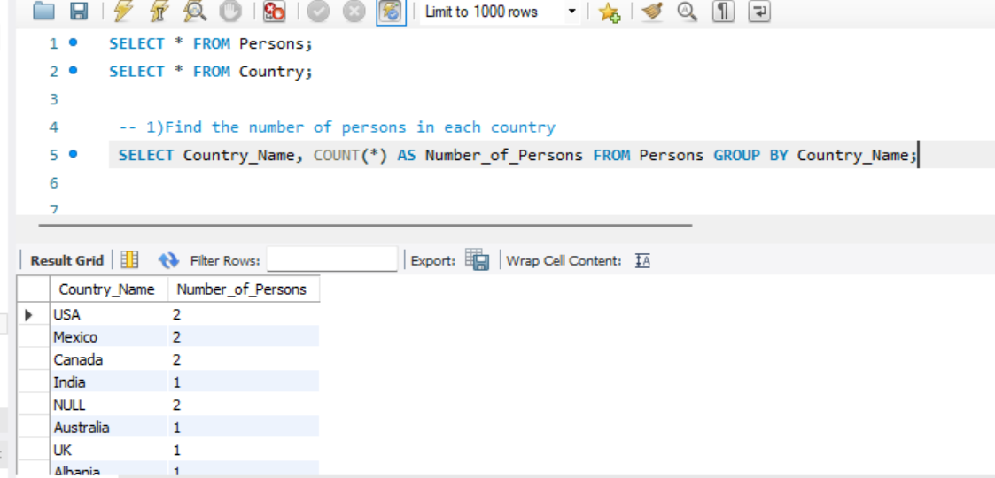

1. Find the number of persons in each country sorted from high to low

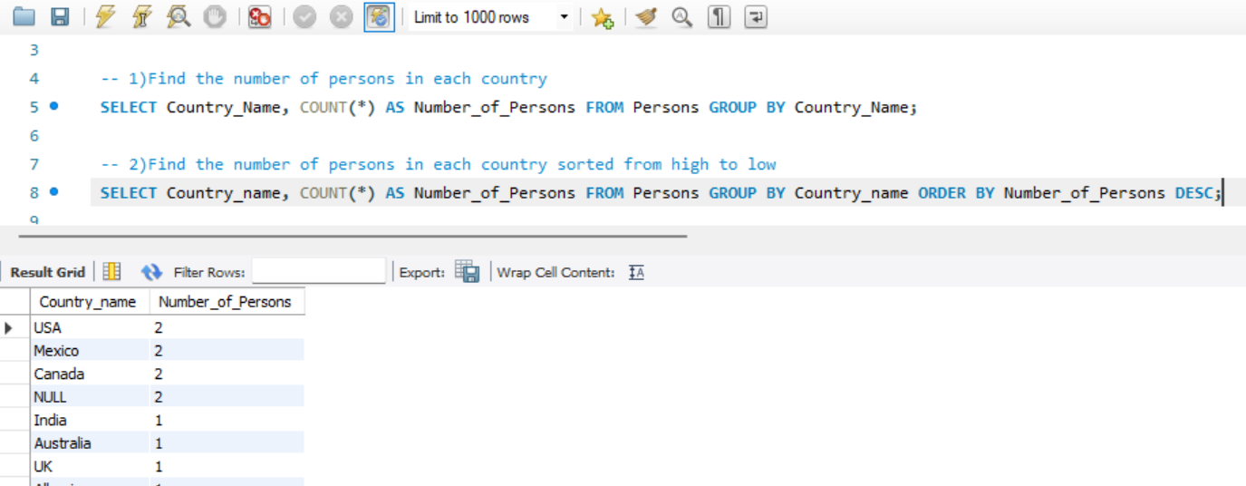

1. Find out an average rating for Persons in respective countries if the average is greater than 3.0

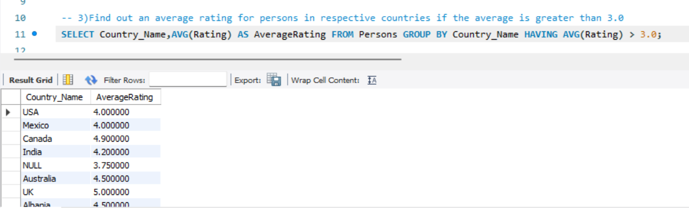

1. Find the countries with the same rating as the USA. (Use Subqueries

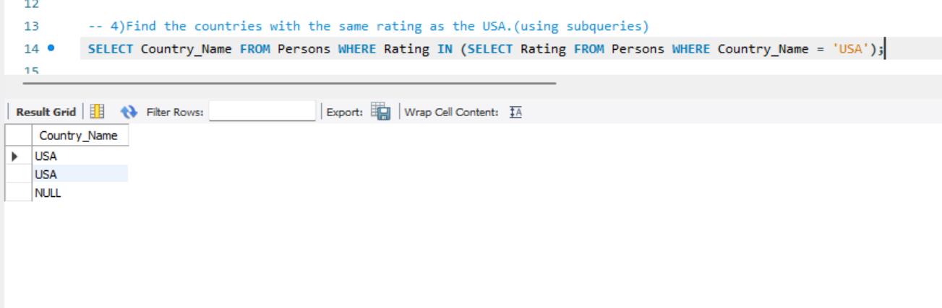

1. Select all countries whose population is greater than the average population of all nations.

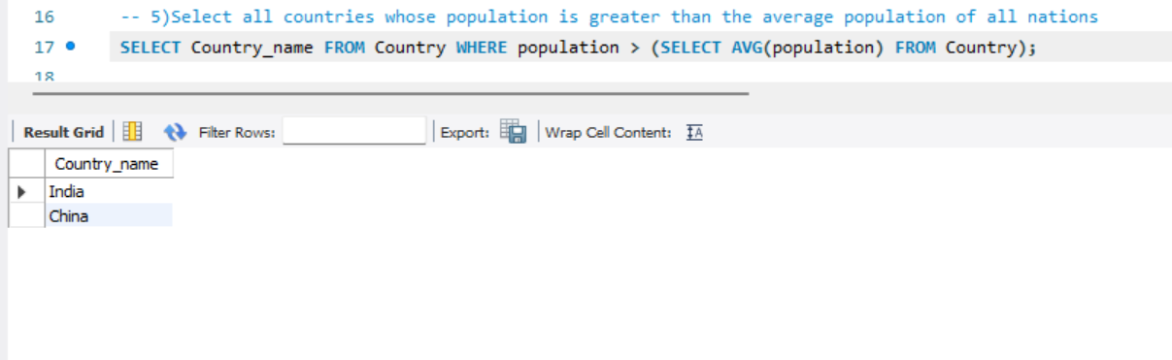

Create a database named Product and Create a table called Customer with the following fields in the Product database: Customer_Id - Make PRIMARY KEY ,First_name ,Last_name ,Email, Phone_no ,Address ,City, State ,Zip_code, Country.

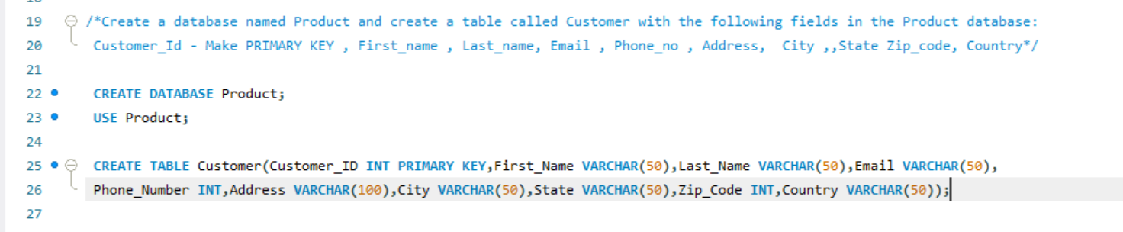

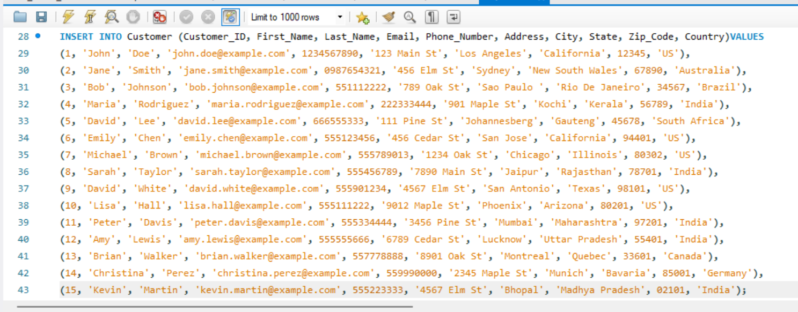

1. Create a view named customer_info for the Customer table that displays Customer’s Full name and email address. Then perform the SELECT operation for the customer_info view.

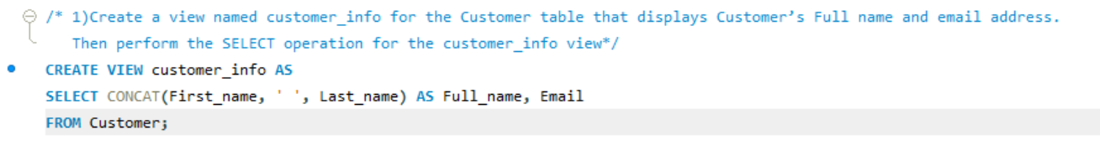

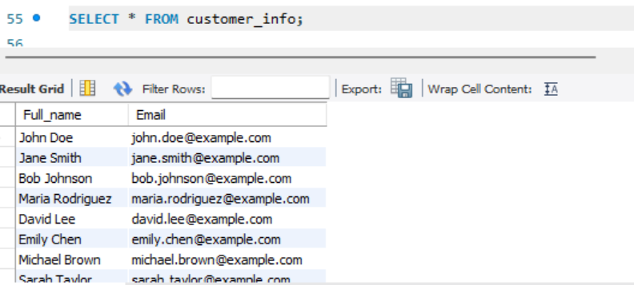

1. Create a view named US_Customers that displays customers located in the US.



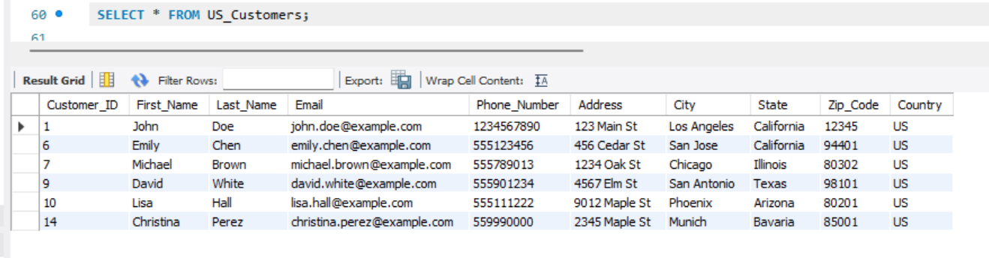

1. Create another view named Customer_details with columns full name(Combine first_name and last_name), email, phone_no, and state.

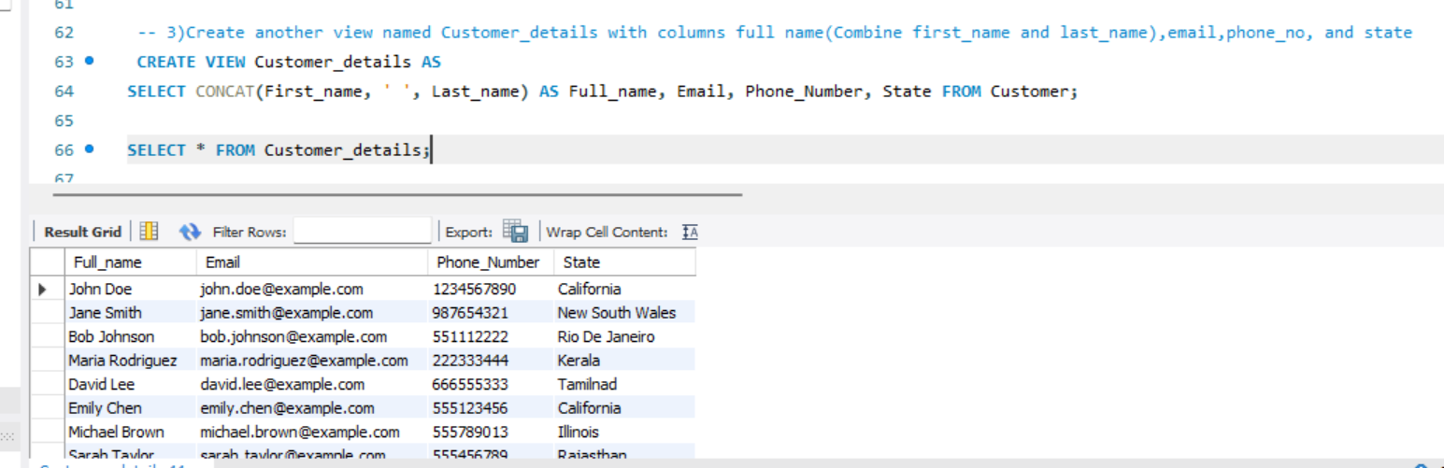

1. Update phone numbers of customers who live in California for Customer_details view.

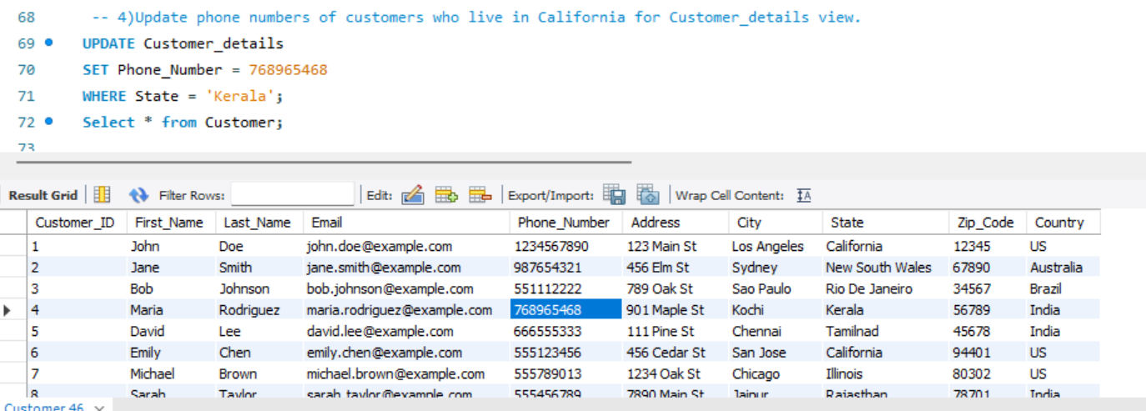

1. Count the number of customers in each state and show only states with more than 5 customers.

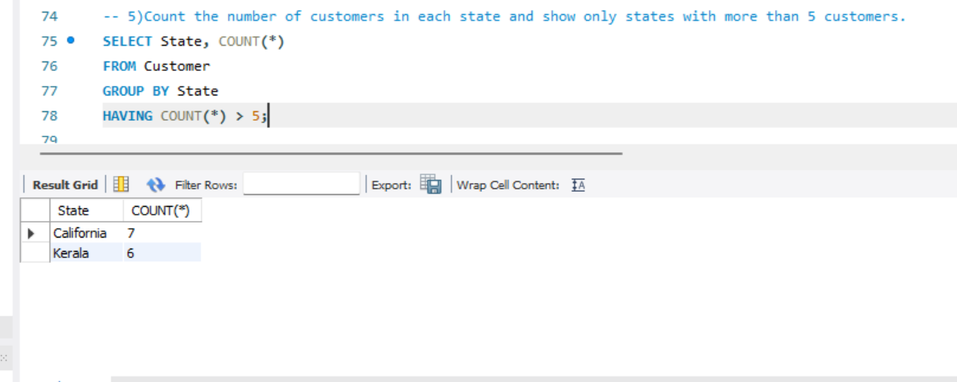

1. Write a query that will return the number of customers in each state, based on the "state" column in the "customer_details" view.

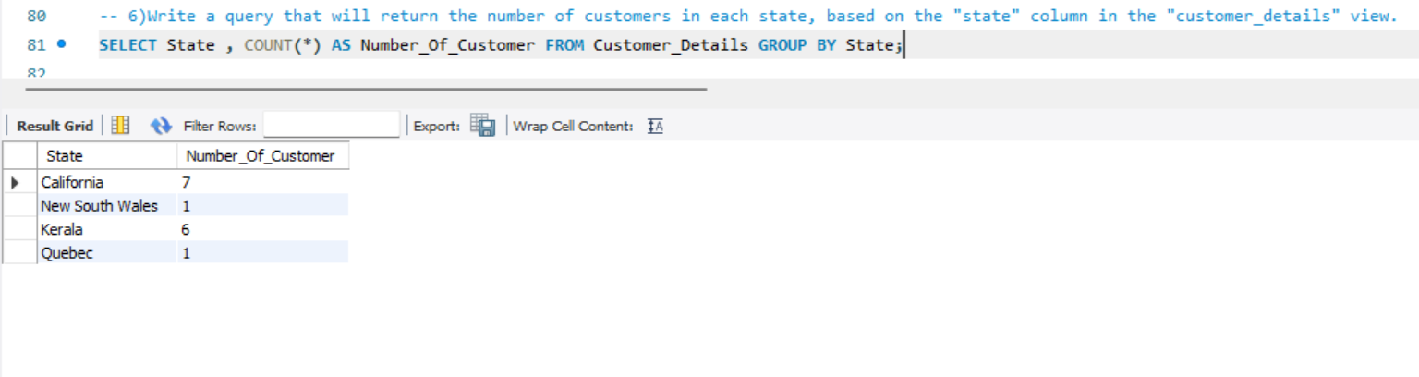

1. Write a query that returns all the columns from the "customer_details" view, sorted by the "state" column in ascending order.

